-To Log-in to your Student Account Center (SAC)-
Our office is here to help you! If you have questions on any steps in this process, please reach out to us!
studentaccounts@greenville.edu or 618-664-7113

1) Log into my.Greenville with your GU Username/Password. After log in, you will be on your home page.
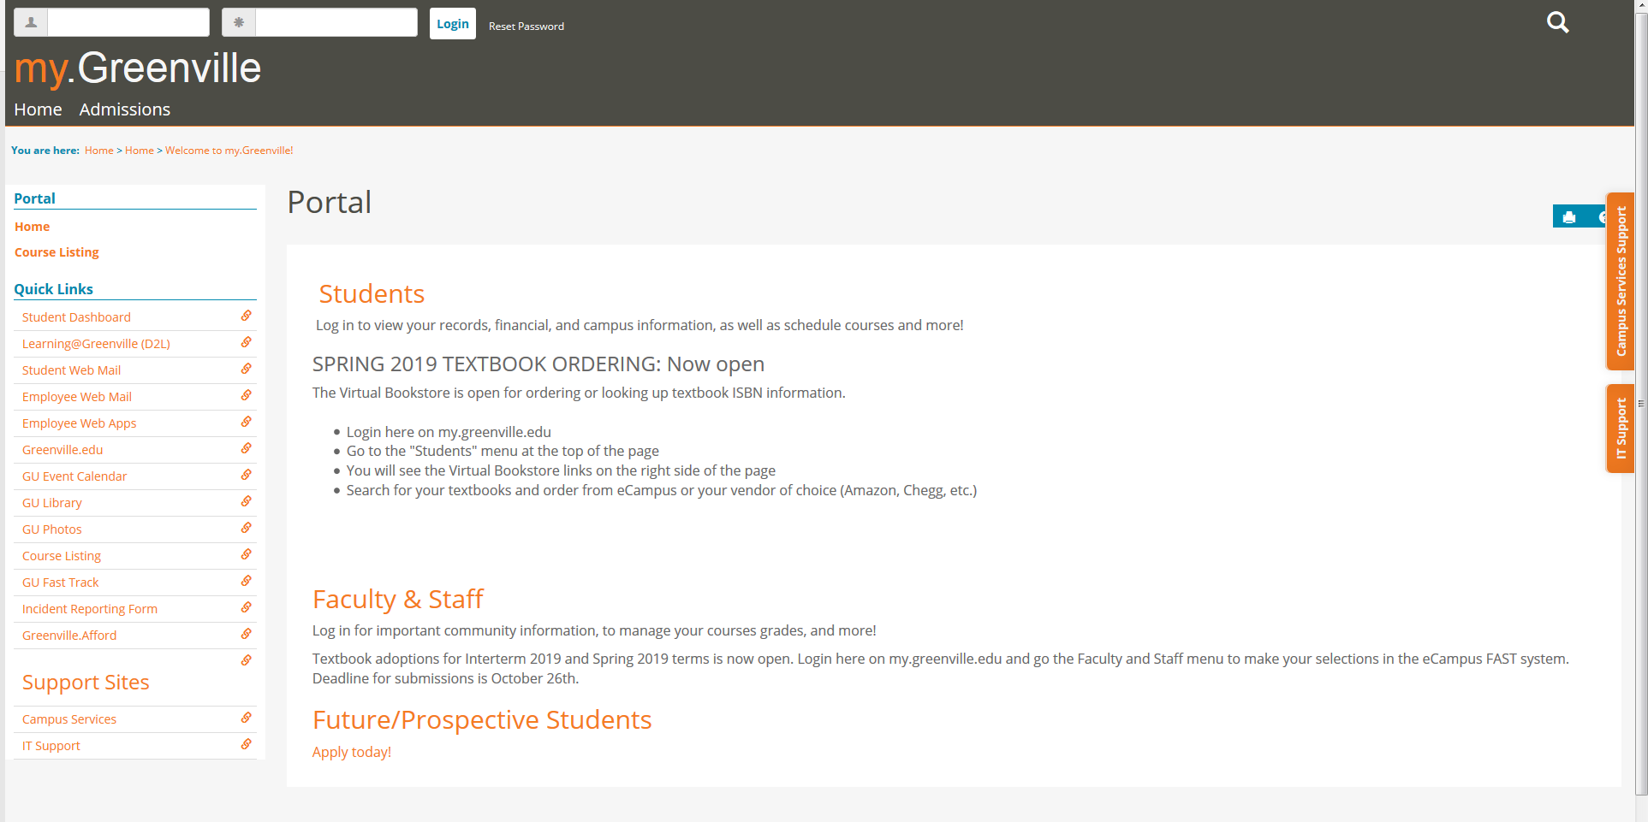
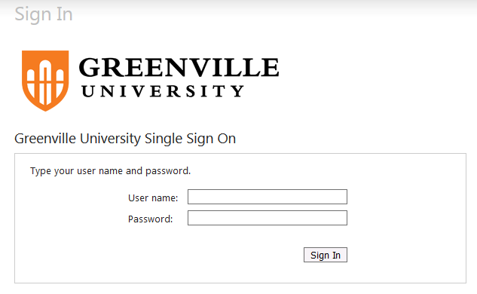
2) Select Students, then my Financials, then Student Account Center Sign In. You will be prompted to sign in again using your GU Username/Password.

3) The first time you sign in to your Student Account Center (SAC), you will be asked to set up Direct Deposit, in case you are ever eligible for a refund. If you do not wish to set that up at this time, simply hit “CONTINUE” (3 times) until you see your Account Summary page.
-Navigating your Student Account Center (SAC)-

4) The Account Summary page shows your Total Amount Due. If you do not have a balance due, you will see $0.00. If you have an overpayment/credit, it will be reflected in parentheses ($1,000.00).
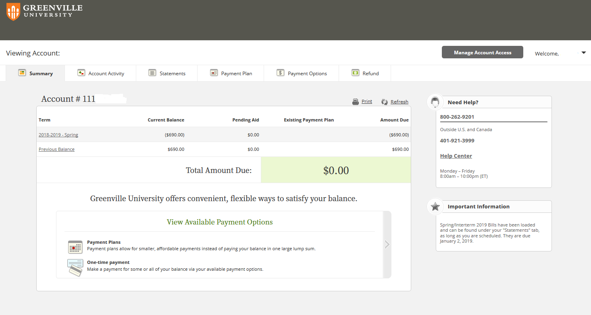

5) By selecting the Account Activity tab, you can see the transactions that make up your Amount Due.
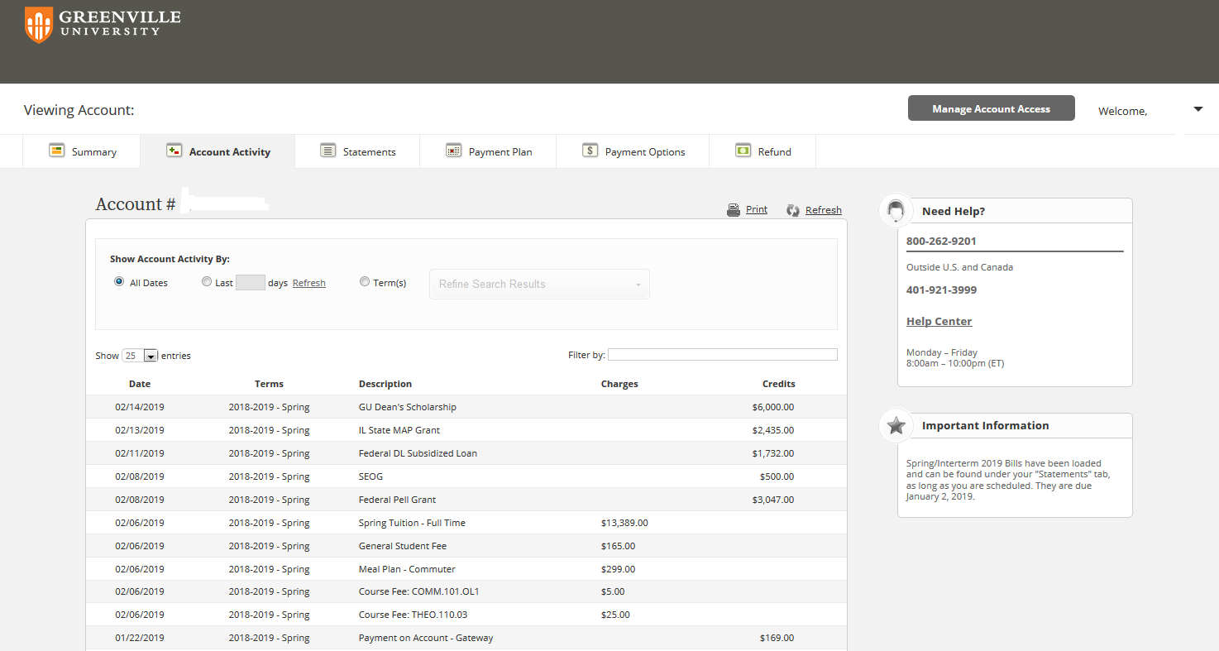
6) By selecting Statements, you can view any current, or past semester Billing Statements. Just hover over the Statement you wish to view, select the Statement, then choose View Your Bill.
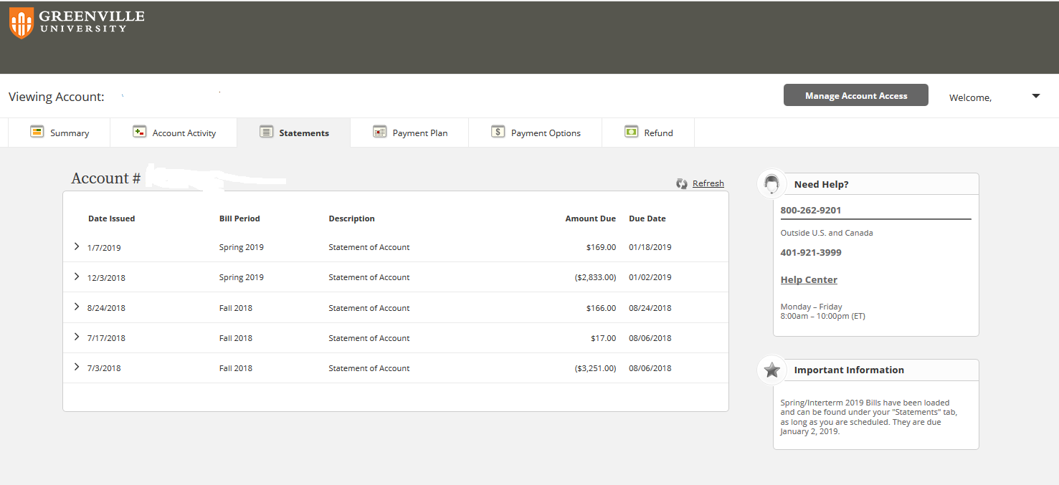

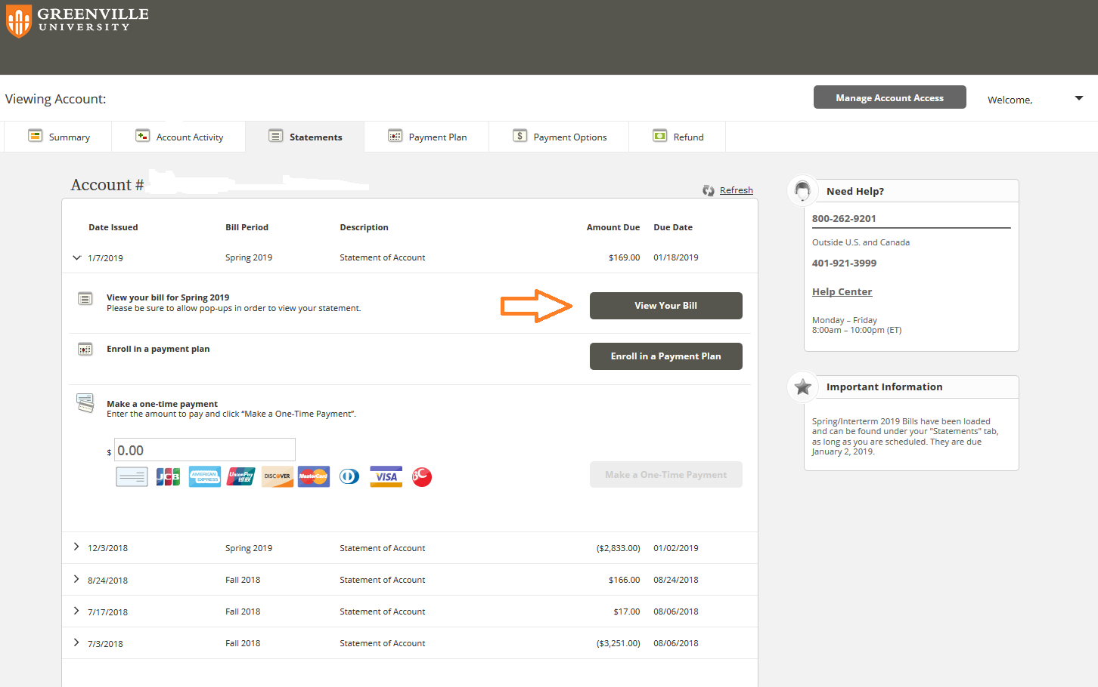

Copy of Bill:
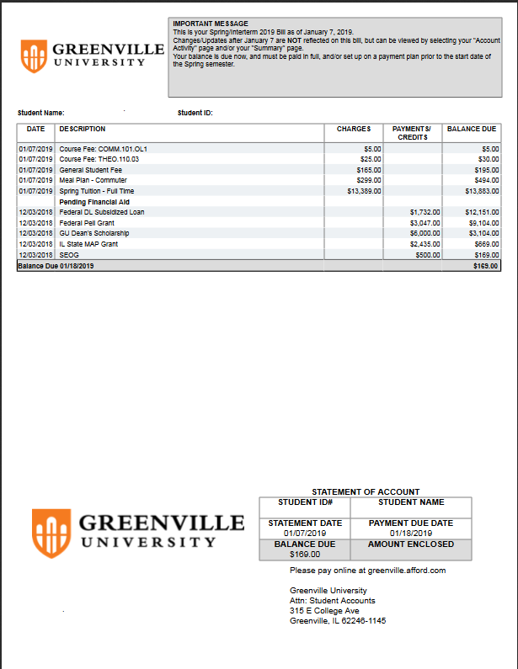

7) By selecting “Payment Plan”, you can set up a new payment plan, or make an adjustment to a current payment plan.
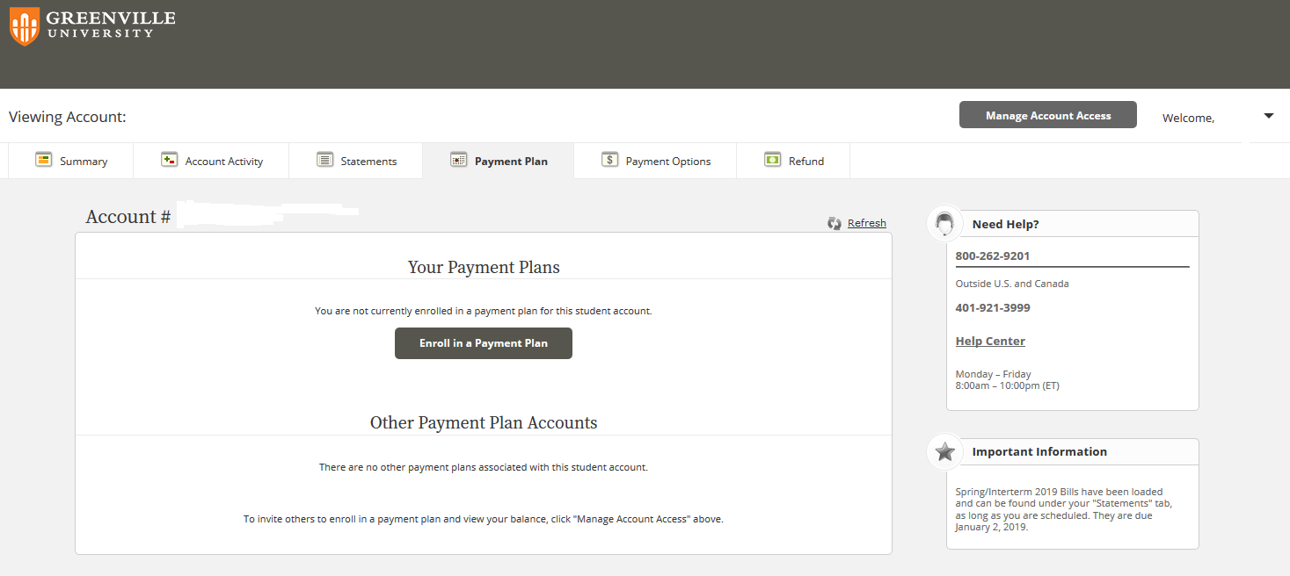

8) By selecting “Payment Options”, you can choose how to pay. We offer a monthly payment plan, or you can pay GU directly with Electronic Check, or any major credit/debit card.
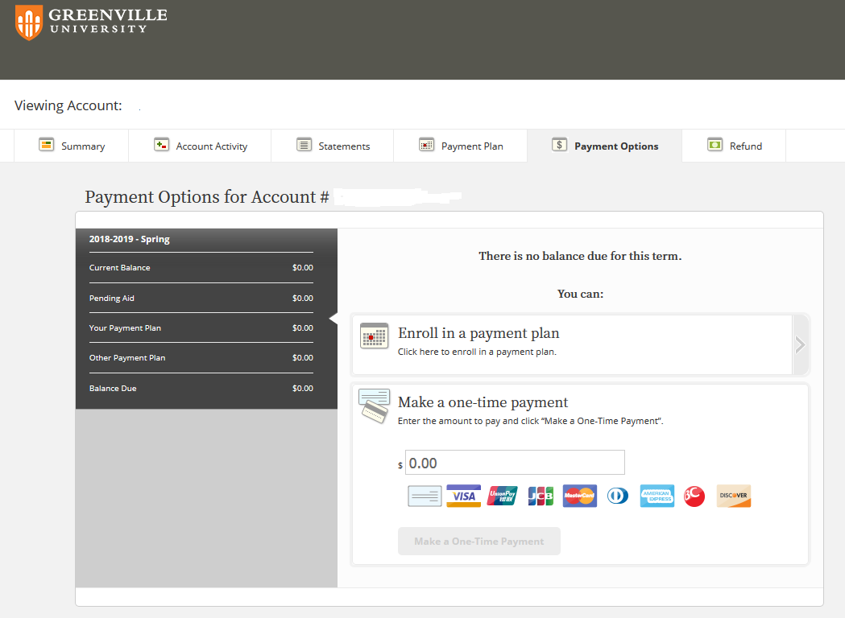
9) By selecting “Refund”, you can track any issued refunds, or set your refund preference. You can set your refund preference for either Direct Deposit, or Paper Check.
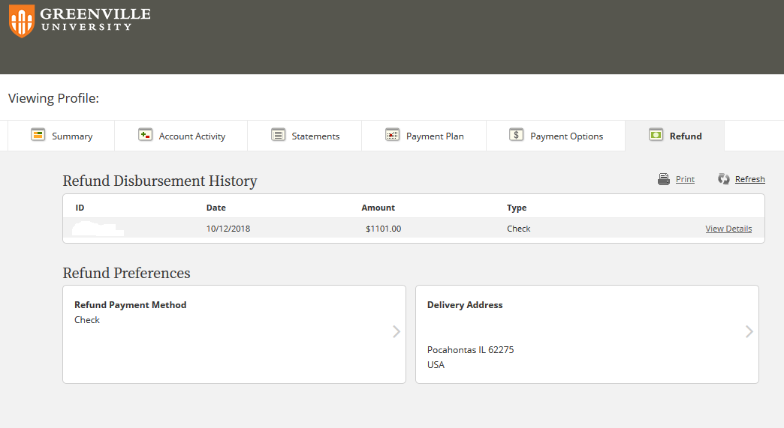

-Additional Student Account Information-
You will be billed prior to the beginning of each semester.
 | Bills are Uploaded to SAC | Bills are Due
Fall | First week of July | Prior to Semester; Early August
Spring | First week of December | Prior to Semester; Early January
Summer | First week of April | Prior to Semester; Early May

*Actual Due Dates will be posted out on SAC.

To view your Bill and your Financial Aid, log into your student portal at My.Greenville. Once logged in, select “Students”, “My Financials”, then “Student Account Center Sign In”. You will be prompted to log-in again. From your Student Account Center (SAC), you can view/print your semester bills, choose to pay your bill directly, or set up a monthly payment plan. If you are receiving a refund, you can also set up your refund preference (EFT, or paper check). For questions about your bill or student account you can contact Student Accounts at studentaccounts@greenville.edu.
Financial Aid and Student Account emails will be sent to your GU Panther Email address. Please review your emails and your Student Account Center frequently for important information and communication.

