How to link assignments to objectives in D2L:

- Important: Be sure to verify that there are proper objectives installed in your course before you link assignments. This task will not work unless objectives are properly installed in the course. Please email assessment@greenville.edu if you need objectives created or have questions locating them in D2L. Please try to only associate one objective in D2L. Failing to do this will produce incorrect data if you try to associate more than one objective. The following screenshots will show you how to check these details:
- Click on edit course:
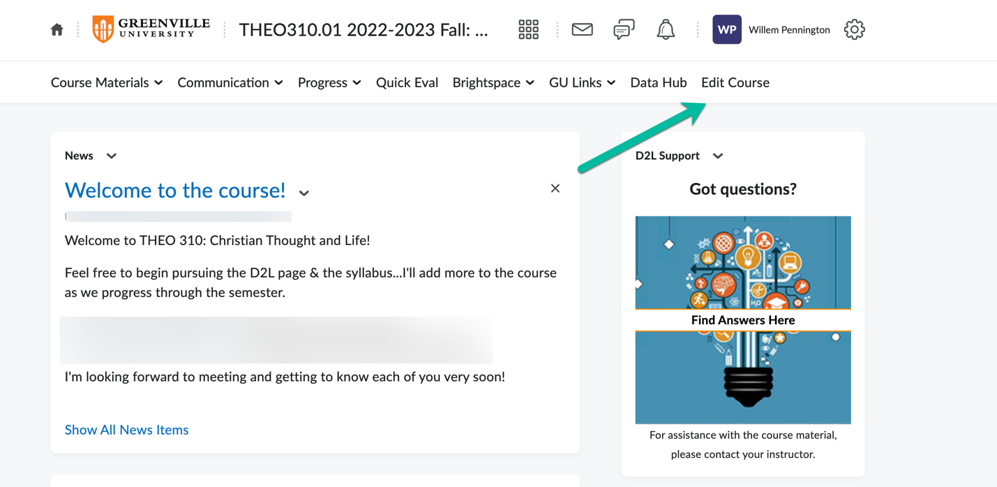
- Scroll down to Course Competencies:
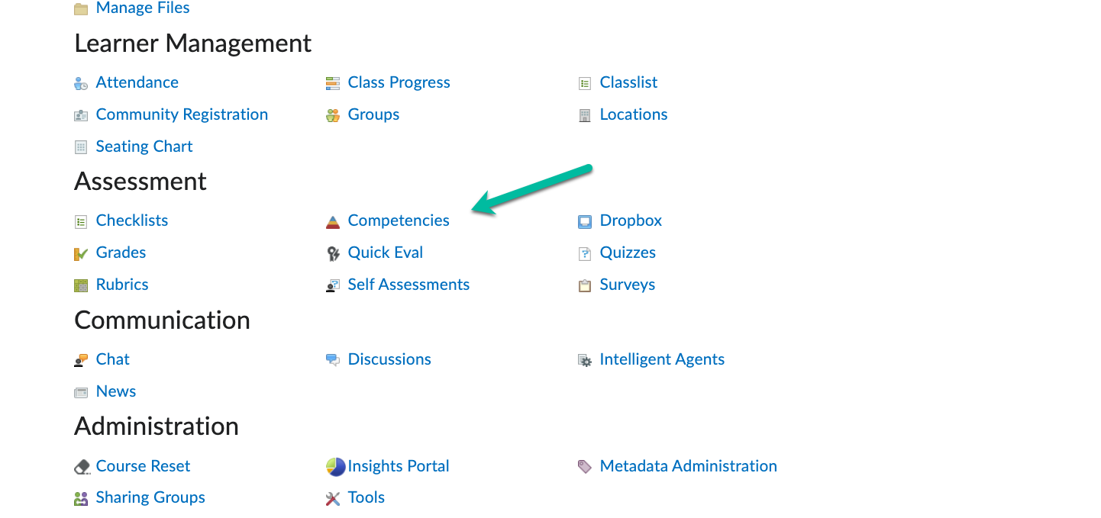
- Click on the plus box and then you will see the current objectives for the course.
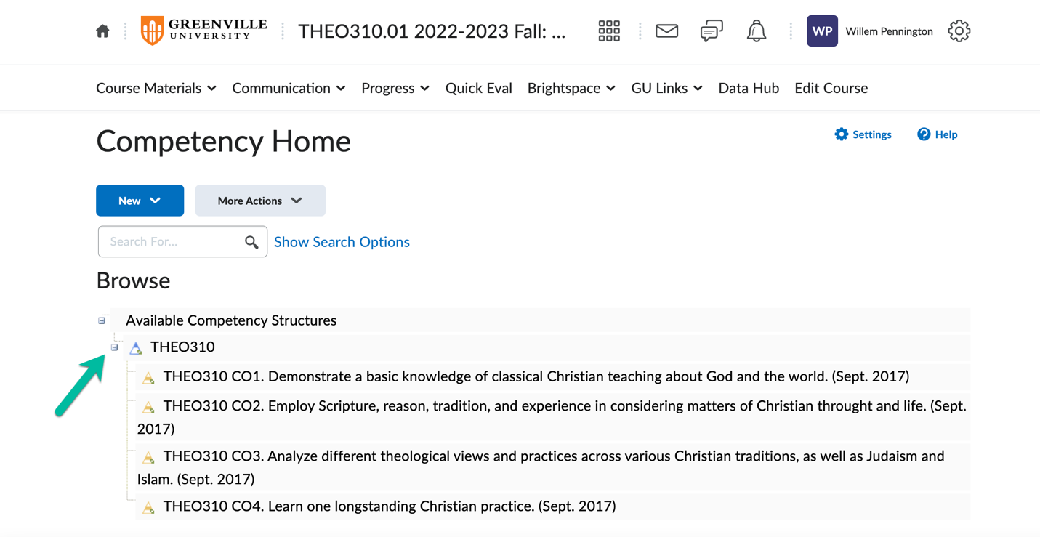
- Once you have verified and done these steps, you are then able to start linking assignments to objectives. If what you see is not the approved set of objectives, please alert our office so that we can update them. Please be sure to follow the objective alignment chart that is housed in your syllabus. This will act as your guide in linking assignments. You will then need to navigate to your gradebook and create a new grade category.
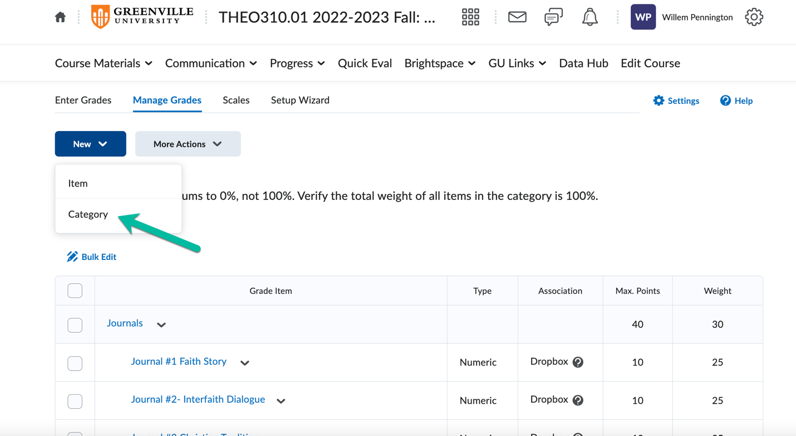
- In the new Category box, name the category “Objective Assessment” and set the weight to zero. You will then need to navigate to restrictions and set it to “hide from users”. This will ensure that students do not see this new grade category.
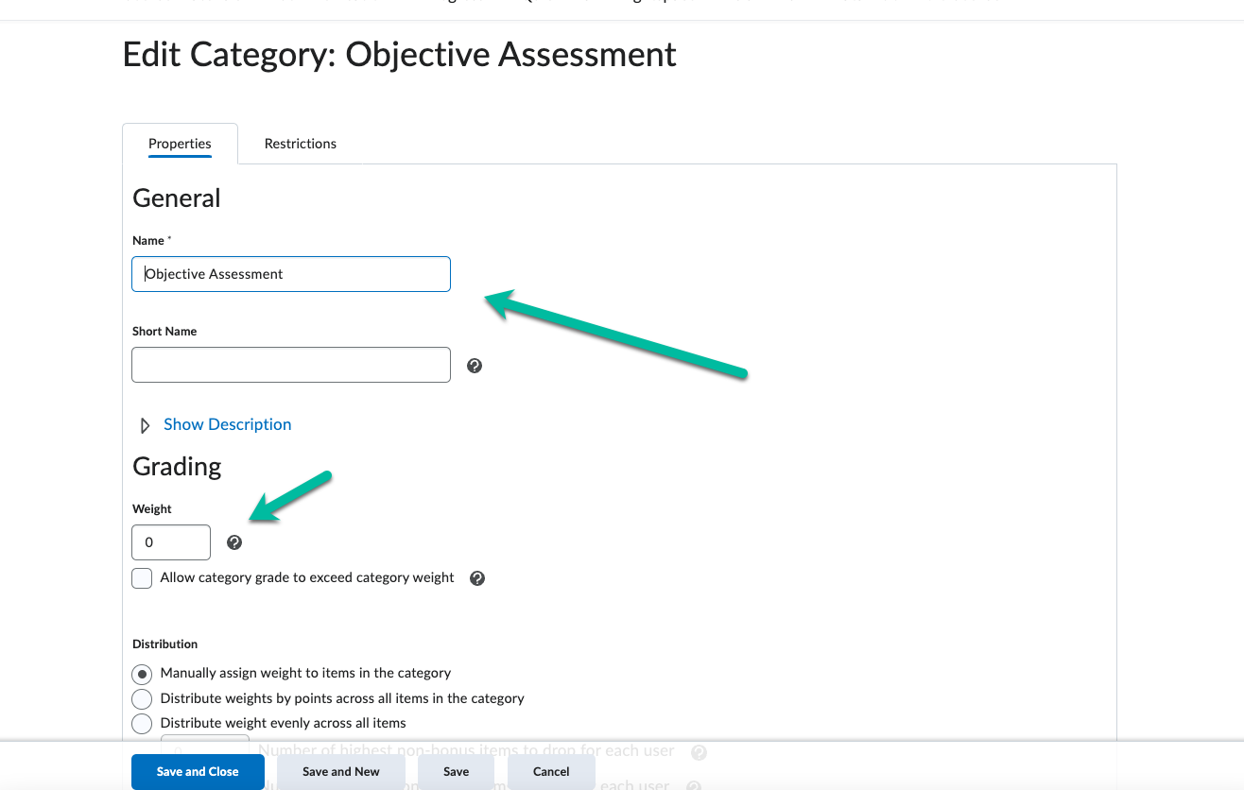
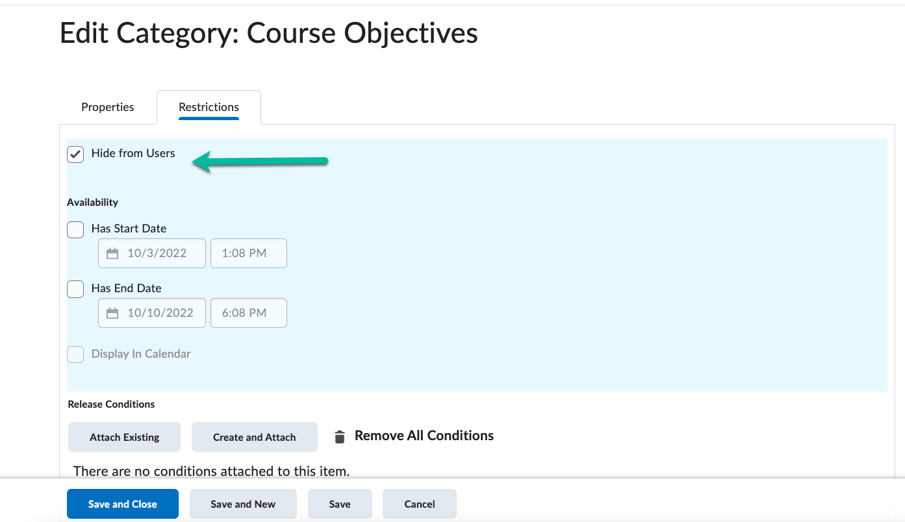
- In the gradebook, select the New Item to begin assigning assignments to objectives. Under the items section, select “calculated”.
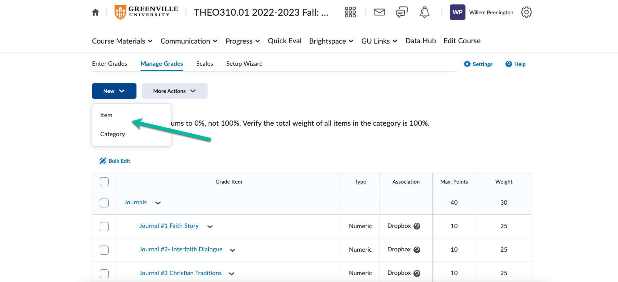
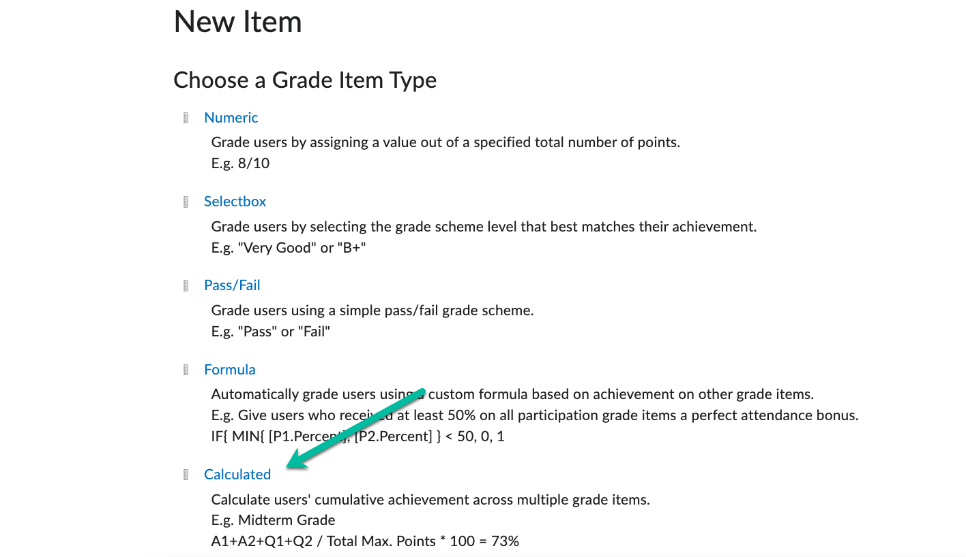
- In the name section, input CO.1 Items. Make sure you select Objective Assessment as the category.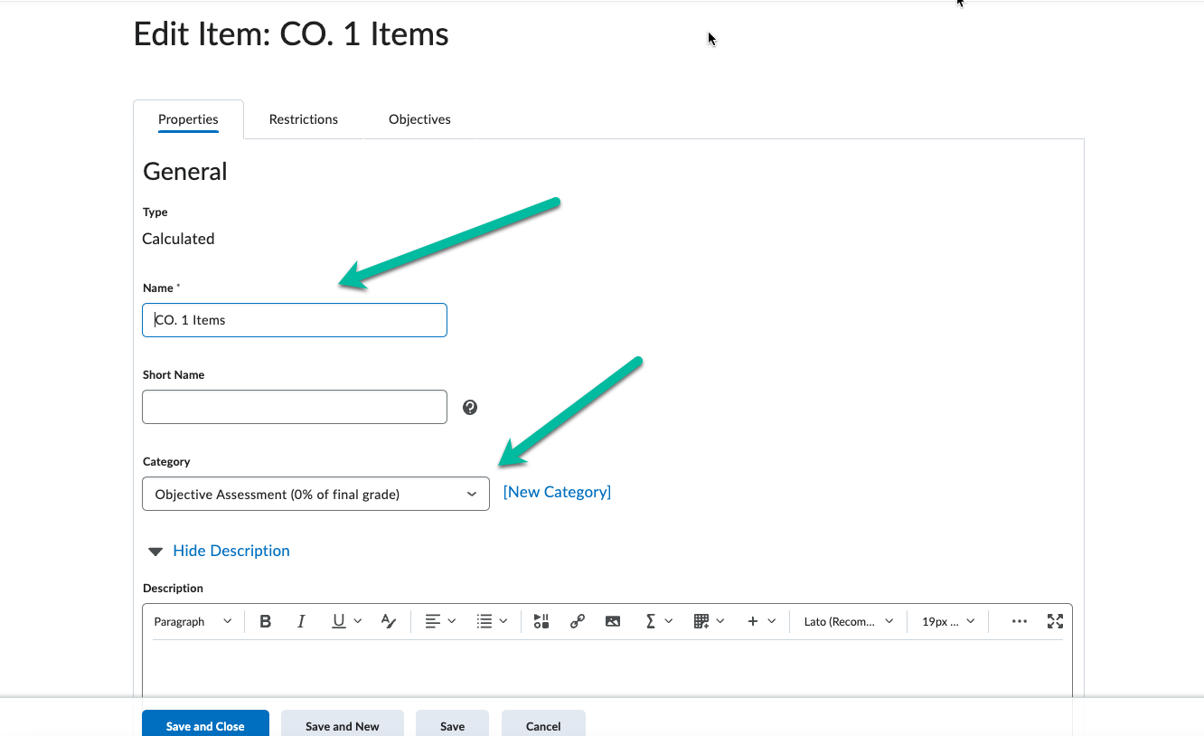

- Select the appropriate assignment that you would like to associate with an objective.
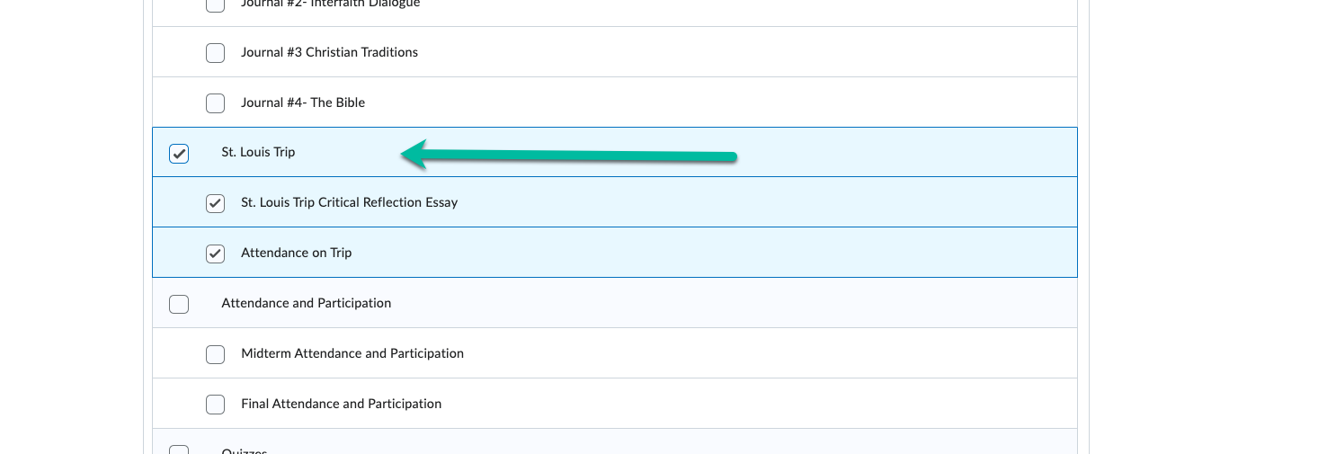
- Navigate to the objectives tab and click on “Associate Learning Objectives”.
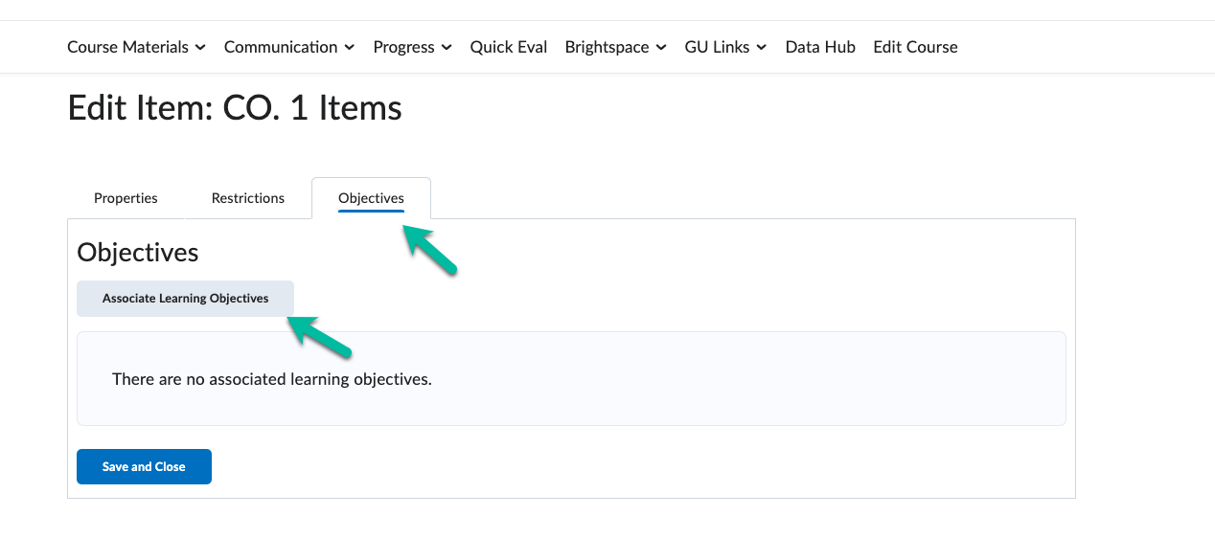
- Click on the plus symbol to view the complete set of course objectives and click on the objective that you are wanting to assess. Hit “add selected” when done.
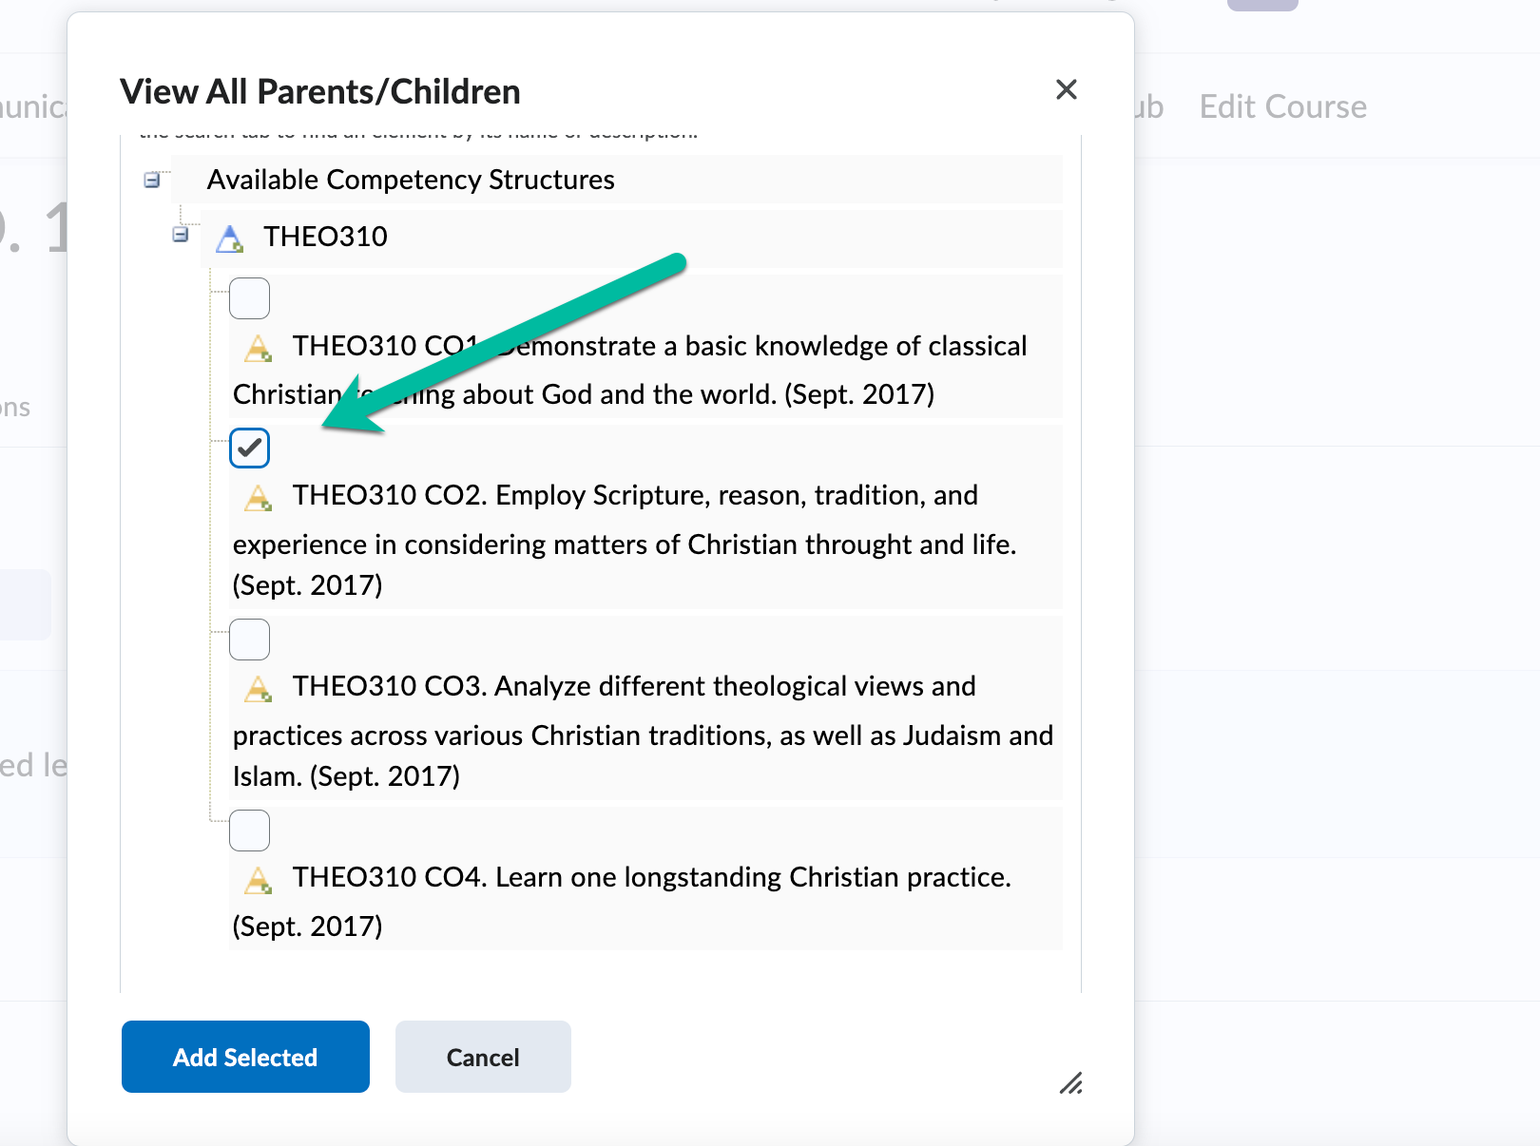
- Hit the drop-down carrot on the course objective and click on “add assessment”
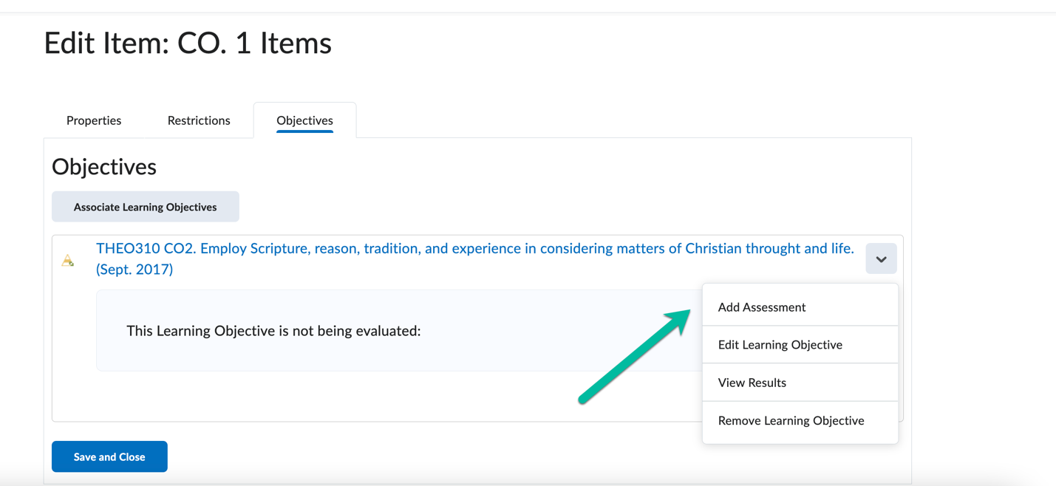
- In the add assessment page, keep the default type to numeric and click the check box for “The activity is required to complete learning objective”. Set the scale to greater than or equal to 70 percent. Those values are set by the assessment office as the standard for achieving an objective. Click save when done.
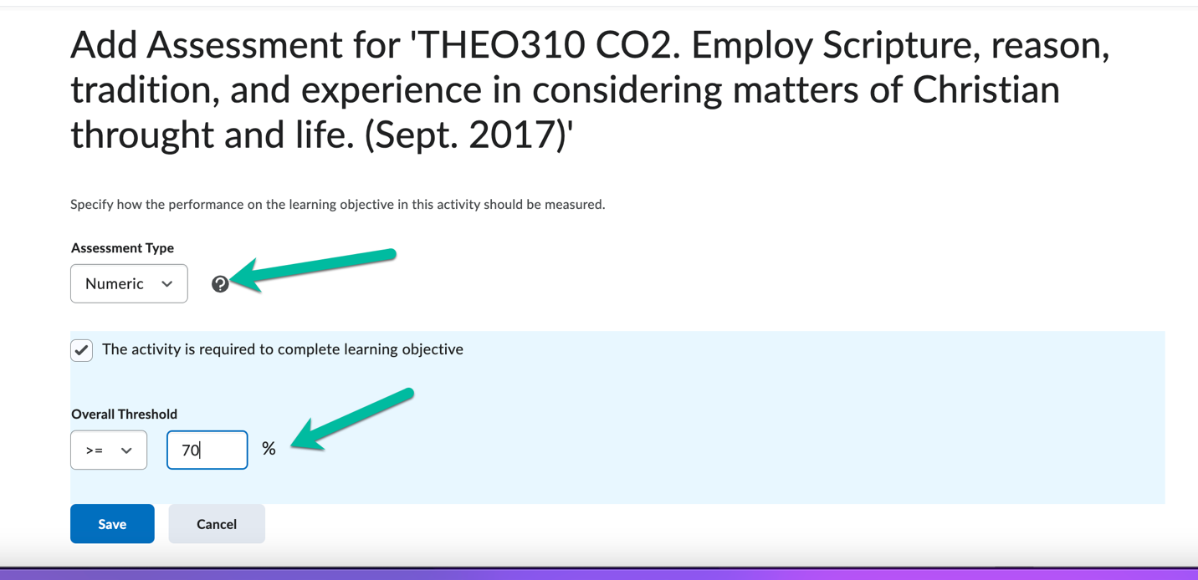

- Complete steps 7 through 14 until all objectives are linked to assignments.

- To view the data at the end of a term, navigate back to the gradebook and click on the dropdown carrot of the objective that you are wanting to see. Click “view statistics” and then you will get a set of data that can then be inputted into your FCARs and End of Year Reports.

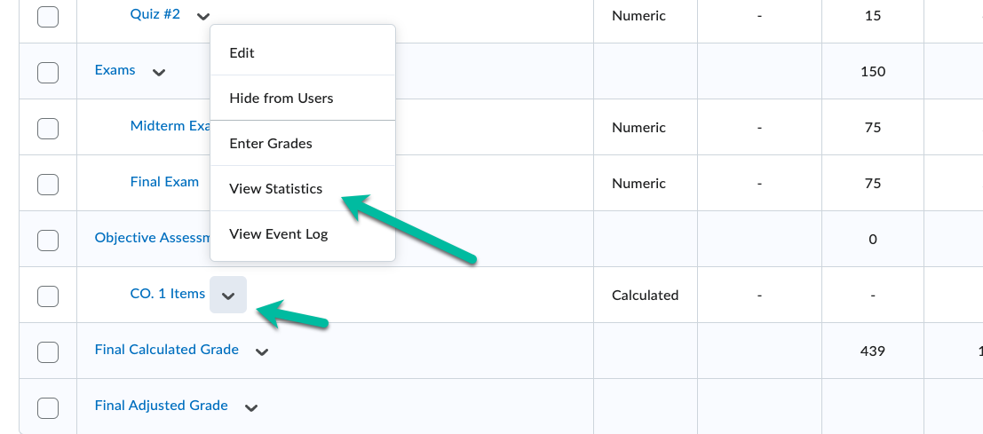

Helpful tip: If the course is being taught again in a different term, please be sure to copy all the data from the current course. This will ensure that all assessment data will be copied over. This step will save you from having to do the linking each time the course is taught next.

